**PS Lab 09**

1)

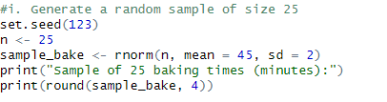

2)

